2016

Jimmi Andersen, Marek Mikitovic and David Papp

Semester Project fourth Semester

16-12-2016

Process Report For Game-Console

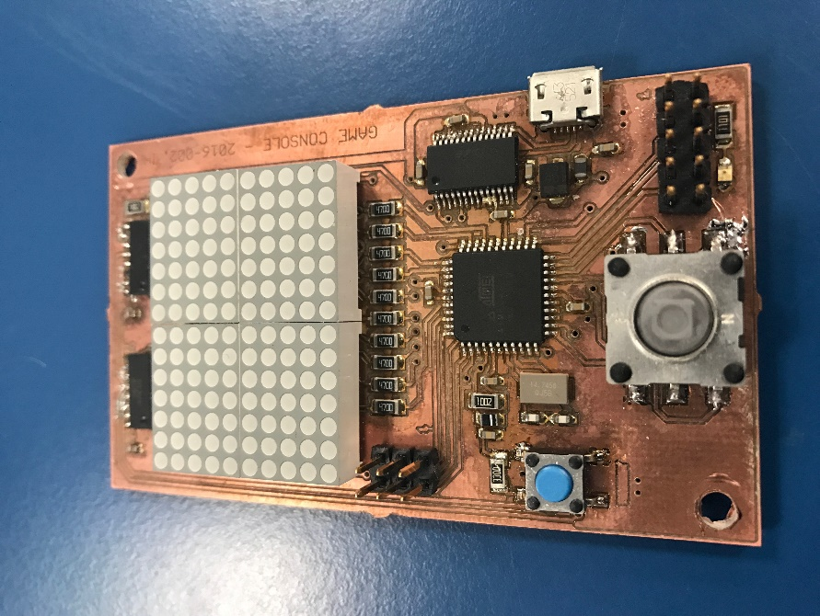

Table of Content.

Abstract. 2

Introduction. 3

Analysis. 4

Requirements. 4

Functional: 4

Non-functional: 4

System Diagram. 4

System timeline. 4

Design. 5

Game Protocol 5

Game Protocol Diagram 5

Task 1 Serial Connection 6

Task 1 Serial Connection Diagram 6

Task 2 Ball 7

Task 2 Ball Diagram 7

Task 3 Player on board 8

Task 3 Player on board Diagram 8

Task 4 Player Pc 9

Task 4 Player Pc Diagram 9

Implementation. 10

Test. 10

Result. 10

Discussion. 10

Conclusion. 10

References. 10